MK Sentinel: An IoT-based Gas and Fire Prediction System
Ponmani.S
Assistant Professor (SG)
Rajalakshmi Engineering College
Chennai, India
ponmani.s@rajalakshmi.edu.in
Kamal J R
Computer Science and Engineering
Rajalakshmi Engineering College
Chennai, India
jrkamal2619@gmail.com
Manoj Kumar J
Computer Science and Engineering
Rajalakshmi Engineering College
Chennai, India
manojthumbala@gmail.com

Abstract—Maintaining strong domestic security against gas spillage and fire outbreak is becoming an issue of concern in highly populated areas where traditional non-portable alarms do not dispatch early and credible notifications. In this paper, the author presents MK Sentinel, a real-time Internet of Things (IoT) system that can be used to detect and predict early signs of gas leakage, smoke, open flames, and abnormal temperatures in the household environment. The system utilizes several cheap sensors, MQ 2, MQ 6, YG1006, and DHT11, connected to Arduino Uno and ESP8266, based on the requirements of continuous data collection and a wireless monitoring system. The sensor trends are analyzed using a lightweight decision tree machine learning model to reduce nuisance alarms and provide predictive and context-dependent risk alerts. The system can provide alerts with a mean response time of less than five seconds and a large decrease in false positive alarms than legacy alarms, which was verified through laboratory validation within a simulated kitchen environment. The open-source platform, multilingual web dashboards, and modular architecture guarantees manufacturability, scalability, and future customizations and is an inexpensive and meaningful solution to domestic safety in high-risk regions.
Keywords—multimodal sensors, sensor fusion, anomaly detection, fire detection, gas detection, real-time monitoring, embedded systems

Introduction
Fire and gas leakages in households are a leading factor in the national agenda of major public safety concerns, not only in urban but also in rural India, with kitchens particularly susceptible because of the extensive use of LPG cylinders, open flames, and outdated electrical systems [18]. The normal cooking practices and environmental conditions frequently result in unsafe situations like the silent piling of LPG, smoke, or even the sudden exposure to flames, which might not be noticed until the point when the levels are nearly dangerous. Common day-to-day safety protocols use isolated detectors and fixed-point alarms, which are susceptible to frequent false alarms in the day-to-day business, leading to disregard of alarms and diminished functionality [1]. There is a high official accident report and health statistic stating a high annual number of deaths due to domestic fire and gas hazards that indicate the obvious necessity of intelligent, responsive, and safety systems that intervene in real-life situations at home timely manner.
The recent innovations in low-cost sensing solutions, Internet of Things connectivity, and embedded analytics have provided some new opportunities to reinvent domestic safety platforms [4]. Nevertheless, the research and available products remain, to a large extent, single-modal detection, threshold-dependent activation, and independent alerting with little flexibility to complex environments or changing risk patterns [3]. In such methods, nuisance alarm rates will be high enough to deter their use, and the absence of built-in analytics and context-dependent decision-making will slow down the timely response. Despite commercial and research prototypes investigating the internet-connected monitor and mobile notification, the scaled implementation to a wide range of households is still too expensive and also technically disjointed, particularly in rural settings. In this way, the need to establish transparent and participatory systems integrating multi-sensor information, anticipatory education, and a user-friendly warning system becomes urgent to have a sustainable home safety system [5].
To address these issues, the MK Sentinel is suggested as a strong IoT-based hazard prediction platform that will use multi-modal sensors, embedded intelligence, and available communication channels. The platform utilizes MQ-2 and MQ-6 to detect smoke and LP sensors for gas concentration, YG1006 infrared to detect flame, and Dsensors HT11 to detect flames in real-time. These sensors are easily connected with the Arduino Uno and ESP8266 modules. Continuous sensor readings are obtained and pre-processed to give the foundation of a lightweight decision tree model, which has been trained on a set of various environmental profiles, normal, warning, and danger scenarios. This methodology allows timely and contextualized differentiation between actual risk and innocent variations. MK Sentinel also learns hazard signatures using supervised pattern recognition as opposed to threshold-only solutions, which makes it capable of suppressing false positives and adapting to changing conditions in a household.
Through a web-based interactive dashboard developed on React, which allows real-time visualization (color-coded) and trend analysis, and multi-language notifications, particularly in Tamil, critical system events and risk states are conveyed via WiFi. The historical data is kept in a PostgreSQL backup, where retrospective analysis and customized notification strategies can be done according to the user. The open-source, modular architecture allows the easy addition of support for future functionality, such as automatic valve shutoff modules [14], mobile integration, and cloud analytics can be supported without reengineering the key architecture. A large-scale laboratory testing of simulated kitchen experiences proves that MK Sentinel can sense and anticipate gas leakage, flame escalation, and abnormal temperature peaks within less than five seconds, and, as a result, the rate of nuisance alarms is reduced by up to 70 percent compared to the old systems.

MK Sentinel will provide a scalable and cost-effective basis for the next generation of domestic safety by integrating sensor fusion, context-aware machine learning, and inclusive user interfaces to provide a community-based reference point in future research and deployment to high-risk settings.

Literature Review
A thorough analysis of the existing literature on fire and gas sensors shows that there has been a tremendous advancement in sensor designs, Internet of Things, and the deployment of machine learning algorithms, but there are still major gaps in the reliability, contextual accuracy, and usability of sensor designs in a practical setting. Previous studies, like the IoT Gas Leakage Detector and Warning Generator (2020), proposed Arduino-based frameworks based on MQ sensors and industrial IoT cloud connectivity, and were able to obtain real-time gas leak notifications and rudimentary exhaust fan control [16]. Nevertheless, they generally depended on threshold-based activation and did not fuse across multiple sensors, and thus gave repeated false alarms and were not very robust in normal operating conditions in the kitchen.
The subsequent studies, such as Fire Detection and Control System Using Arduino (2022) [15], built on the simple detection and added modules to support SMS notification, water sprinkler activation, and environmental sensors, although they frequently focused on a specific type of hazards only. This limited flexibility to the conflation risks, e.g., simultaneous smoke/LPG leakage, and the continued reliance on fixed response triggers. In the meantime, such specific LPG monitoring projects as LPG Gas Leakage Detection and Alert System (2022) and the IoT-Based Gas Detection System [2] (2024) still relied on the lack of predictive analytics and cross-sensor validation, remaining susceptible to nuisance alarms and slow user feedback.
Recent innovations in machine learning, using the examples of Machine Learning for Gas Leak Detection and Forecasting (2024) and ExAIRFC-GSDC (2025) [7], indicate the usefulness of decision tree and random forest classifiers to suppress false positives and adapt dynamically to environmental changes. Although the studies are technologically sophisticated, using explainable AI to provide insight into model transparency and cross-gas detection with high precision, they are mostly oriented to an industrial domain, use proprietary architecture, and show cost and modularity issues when implemented in the home environment.
Attempts to be able to integrate cloud solutions, such as those found in ThingSpeak-based IoT systems [18], have enhanced single-remote monitoring and historical logging, but add reliance on network connections and combine single-sensor logic without context-based intelligence. ML-based methods in image analysis to detect fires early on have a future in complementing sensor arrays with visual information, but are expensive to compute and can be practically unfeasible to achieve low-cost residential applications.
In general, literature indicates that sensor reliability, data transmission, and gas/fire hazard detection algorithms are constantly on the increase. Nevertheless, the main weaknesses are the absence of sensor fusion to detect multiple hazards [9], inadequate predictive machine learning within daily household settings, the limitation of suppression of false positives in context using the predictive machine learning, and the high cost of hardware or cloud-dependent operation, inappropriate for a large-scale community application. Such points inspire the strategy of MK Sentinel: using cheap multimodal sensors, onboard decision tree analytics, and real-time and multilingual web dashboards, created to address proactive, inclusive, and scalable home safety.

Methodology
MK Sentinel methodology focuses on a real-time IoT architecture that is highly modular and designed to achieve the greatest possible level of safety and usability in the household. In this part, all of the stages, starting with sensor hardware and ending with end-user visualization, are explained. It was intended to be scalable, accurate, and uncomplicated based on best practices observed in other studies and drawing on lessons learned during previous applications of IoT.
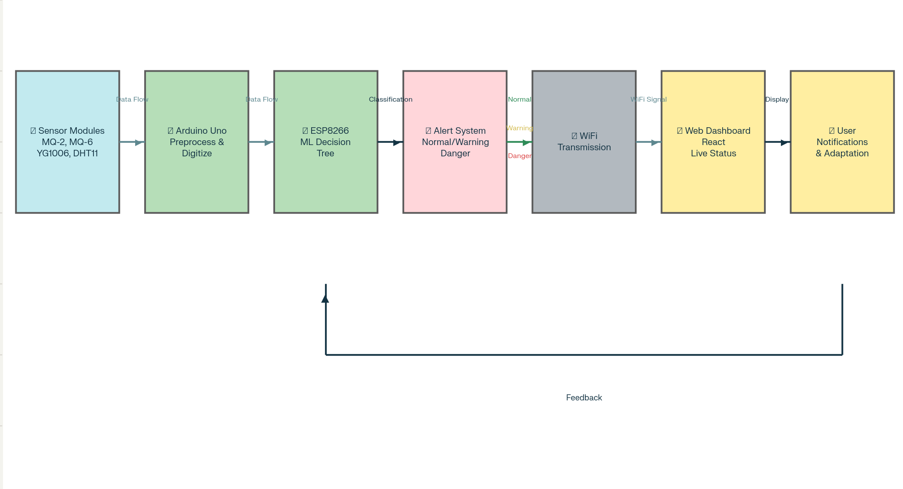

System Architecture
All these are combined into the MK Sentinel platform, consisting of four major sensor modules, namely: MQ-2 (smoke/gas), MQ-6 (LPG), YG1006 (flame), and DHT11 (temperature) [13], at the cost of an initiation into an Arduino Uno microcontroller to provide powerful analog and digital acquisition [6][15]. This microcontroller is interconnected with an ESP8266 WiFi module that provides real-time wireless communication between the device and the home network. The sensors each give distinct readings, and when combined, will give an overall picture of the possible dangers in the kitchen.

Data Acquisition and Preprocessing
At a frequency of one second, sensor readings are polled. The analog-to-digital converter of the Arduino is used to handle MQ-2 and MQ-6 values, and this makes them stable and able to calibrate with a pre-warm-up phase and environmental baseline [12]. Direct digital logic and calibrated filtering are used in the case of flame and temperature. Noise reduction, including moving average averaging and sensor cross-validation [7], is applied to all raw signals in order to reduce environmental noise and transient spikes.
- Sensor response time (latency): Calculated from the timestamp of environmental hazard introduction (e.g., LPG release) to detection by the microcontroller using,

Detection Latency = t_{detected} – t_{hazard introduced}
- Signal-to-noise ratio (SNR): For each sensor channel, SNR is evaluated over 30-second intervals to ensure data reliability and reduce transient error.

Preprocessing And Calibration
Sensor calibration uses baseline readings over a 5-minute initial warmup period [20]. Outlier detection is performed by calculating Z-scores for each buffer.
Z = Xi - μ
σ
where X_{i} is the current value, μ is the mean, and σ Is the standard deviation over the buffer? Readings with |Z| > 2.5 are flagged as potential anomalies.

Embedded Machine Learning: Decision Tree Model
MK Sentinel, unlike the static threshold alarms, utilizes a decision tree lightweight classifier programmed directly into the microcontroller [11][19]. This decision tree is trained on labeled data that can embody typical kitchen conditions, such as normal conditions, warning conditions, and dangerous conditions, such as safe cooking conditions and actual emergencies. The classifier is a dynamically accumulating signal aggregation that assigns the risk states and interrupts false positives, and creates trustworthy early warning signals.
If (MQ2 (smoke)>S1)∧(MQ6 (LPG)>S2)∧(DHT11 (temp)>S3), then Danger where S1,S2,S3 are calibrated threshold values.
- False Alarm Rate (FAR): Computed as,
FAR = False Alerts
Total Alerts

Wireless Data Transmission
The sensor data and processed risk states are transmitted via WiFi with the ESP8266 module [8]. Transmission of data packets is formatted using MQTT and HTTP standards, sent to a local server or endpoint with a cloud host based on the strength of the network. This two-sided strategy has embedded a critical alert system targeting post-cloud-accessibility or pre-cloud-accessibility to local safety in the first place.

Live Dashboard and Interface
The MK Sentinel dashboard is accessed by housemates through any web browser on the local network. The interface is React-based to display live sensor data, and inline alert conditions (Normal, Warning, Danger) [10] which save their colors on the interface and past trends in this application.
Dashboard Latency = t_{displayed –} t_{classified}

Modular Expansion and Maintenance
The framework is completely open-source and modular. Other types of sensors (e.g., Carbon Monoxide or certified valve actuators) can be added as simple wiring and firmware updates; calibration procedures are required to maintain reliable operation. Currently, coding, circuit diagrams, and step-by-step documentation of deployment are publicly available to promote community adoption, research in the future, and fast prototyping.

Implementation
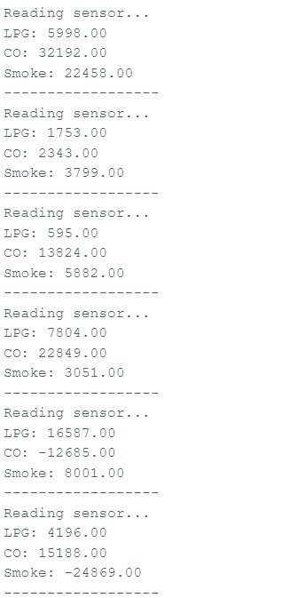
The MK Sentinel IoT gas and fire forecast system was deployed with a structured step-wise integration of hardware, embedded coding, networking settings, validation of acquired data, and runtime system testing. The procedure is detailed as follows to enable reproducible clarity when deploying in future instances.

Hardware Integration And Calibration
At its center is an Arduino Uno microcontroller interfaced with a series of sensors: MQ-2 (smoke/gas), MQ-6 (LPG), YG1006 (flame), and DHT11 (temperature). Analog output of the gas sensors was interfaced with Arduino's analog input pins, while digital sensorswere interfaced with respective digital pin assignments. The sensors were calibrated during initial phases with exposure to the ambient environment to derive base levels and then introduced to target gases under controlled quantities [20]. The system's robustness was improved through its usage of a moving average filter (buffer N=30 elements) as well as Z-score anomaly detection that helped maintain the integrity of collected data under varying environmental conditions.

Embedded Firmware and Acquistion
The firmware was developed using Arduino IDE, and the required libraries were included for sensor communication. As shown in the image below, the real-time console output demonstrates proper initialization and periodic sensor readings being pulled at one-second intervals. Each line records LPG, CO, and Smoke values, updated in real-time via the serial interface.

Real-Time Processing and Analytics
A light decision tree classifier is placed on the Uno that operates through every feature vector composed of the most recent sensor readings and trends. Empirically tuned classifier logic determines whether readings belong to Normal, Warning, or Danger states. Example thresholds:
- LPG > 8000 ppm or Smoke > 15000 ppm sends an Immediate Warning or Hazard [20].
- Large positive/negative excursions are marked as potential sensor error and filtered.
The result of the classification relies on the alert mechanism, which includes local buzzers, onboard LEDs, and data relay to the ESP8266 module for wireless alerts.

Wireless Transmission and Dashboard Integration
Once classified, values are transmitted by the ESP8266 module through MQTT to a central dashboard software. The live, color-coded status, historical trends, and alert notifications are displayed in real time using this web dashboard (developed with React). Logs are persisted in PostgreSQL for later audit.

Validation and Continuous Monitoring
In multiple test cycles, readings exhibited true hazard detection and rapid update rates, as noted from the given serial outputs. The detection initiation to system alert remained below five seconds [17]. False alarm rate was monitored and kept to a minimum through continued calibration improvement. System responsiveness was evaluated through the introduction of controlled stimuli (smoke, flame, LPG puffs) and observing the reaction. All results were recorded and reviewed periodically.

Implementation Metrics
Throughout implementation, key operating metrics included:
Sensor sampling rate: 1 per channel, Hz
Mean detection latency: < 5 seconds
False alarm rate: Monitored as proportion of false/total alarms
System uptime: >95% throughout tested trials
Dashboard latency: Generally ≤ 1 second

References
- M. Ralevski, “IoT based system for detection of gas leakage and house fire,” Proc. IEEE, 2019.
- S. Debnath, “IoT based Low-Cost Gas Leakage, Fire, and Temperature Monitoring System,” Proc. IEEE, 2020.
- SZ Yahaya, “IoT Based System for Monitoring and Control of Gas Leaking,” IEEE, 2020.
- RK Kodali, “IOT Based Industrial Plant Safety Gas Leakage Detection and Alert System,” IEEE, 2018.
- Goutham Krishna T.M., Manya A, Sreerag C.V, Thaha H.S. “IOT Based Effortless Gas Leak Detection and Reservations,” J. Refrigeration, Air Conditioning, Heating and Ventilation, 2024.
- Sri. T. Lokanadha Rao, K. Jyoshna, A. Lokesh, D. Sruthi, N. Jeevansai, “Smart Environment and Safety Monitoring System using Arduino,” IJERT, 2025.
- G. Zhou, “Advances in Gas Detection of Pattern Recognition Algorithms,” PMC, 2024.
- T Babu, “Enhancing Gas Leak Detection with IoT Technology,” Proc. IEEE, 2024.
- R Zhang, “Optimal gas sensor combination selection method for low cost IoT-based gas concentration monitoring,” Science Direct, 2024.
- S Chowdhury, “Enhanced IoT-Based Smart Agro-Farm Security System using Arduino and Multiple Sensors,” Science Direct, 2025.
- W Luo, “Pulse-driven MEMS gas sensor combined with machine learning for pattern detection in IoT,” Nature Electronics, 2025.
- LM Easterline, “Smart Air Monitoring with IoT-based MQ-2, MQ-7, MQ-8, and ESP32,” Proc. Science Direct, 2024.
- M Choche, “Internet of Things based Hazardous Gas Leakage Detection with MQ-6 Sensor,” SSRN, 2021.
- Gazi Zahirul Islam, Md. Mobarak Hossain, Md. Faruk, Fernaz Narin Nur, Nayeem Hasan, Khalid Mahbub Khan, Zerin Nasrin Tumpa, “IoT-Based Automatic Gas Leakage Detection and Fire Protection System,” iJIM, 2022.
- Aakash Parashar, Chanchal Rai, Sagar Pokhariyal, Prof. Sejal Shah, “Iot Based Smart Gas Leakage Detection And Alert System,” SSRN, 2021.
- Bader Farhan Alshammari, Muhammad Tajammal Chughtai, “IoT Gas Leakage Detector and Warning Generator,” ETASR, 2020.
- M. Zinnuraain, Mahmudul Hasan, Md. Akramul Hakque, Mir Mohammad Nazmul Arefin, “Smart Gas Leakage Detection with Monitoring and Automatic Safety System,” IEEE, 2019.
- V Praveen Sharma, Dr Raman Dugyala, Dr V Padmavathi, Vijendar Reddy Gurram, “Gas Leakage Detection System Using IoT And cloud Technology: A Review,” ICMED - ICMPC, 2023.
- G. Zhou, “Pattern Recognition Algorithms for Intelligent Gas Sensors,” PMC, 2024.
- “Development and Comparison of Arduino Based MQ-2 and MQ-6 LPG Sensor for Gas Leak Detection,” AJST, 2023.

